CS 340 Project Two README:
Project Overview
For this project, I created a dashboard application for Grazioso Salvare that allows users to view and interact with animal shelter data stored in MongoDB. The purpose of the dashboard is to help identify dogs that may be good candidates for different types of rescue training. Users can filter the available animals based on rescue categories, view the results in a data table, and see additional information through charts and a map.
The dashboard was developed using Python, MongoDB, and Dash. The project also builds on the CRUD module that was created in Project One to connect the dashboard to the database.
Required Functionality
The dashboard allows users to filter animal records using four different options: Water Rescue, Mountain or Wilderness Rescue, Disaster or Individual Tracking, and Rest. When a filter is selected, the data table automatically updates to display only the animals that meet the criteria for that rescue category.
The dashboard also includes a pie chart that updates based on the filtered records and shows the breed distribution of the selected animals. In addition, a geolocation map displays the location of the selected animal record from the data table.
The Grazioso Salvare logo and my name were included on the dashboard to meet the project requirements.

Screenshot 1: Rest Dashboard
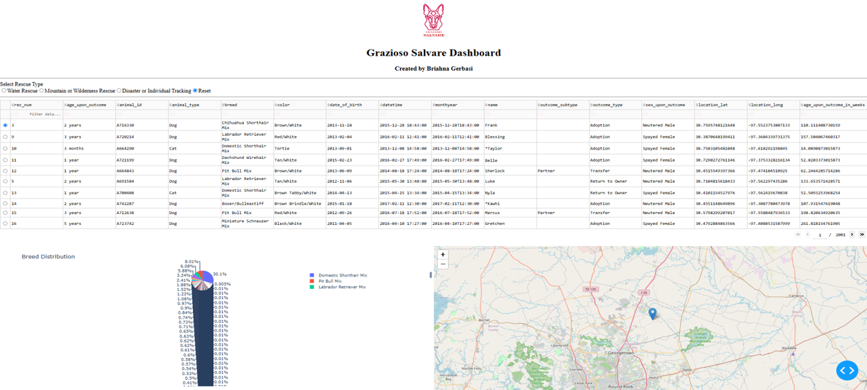

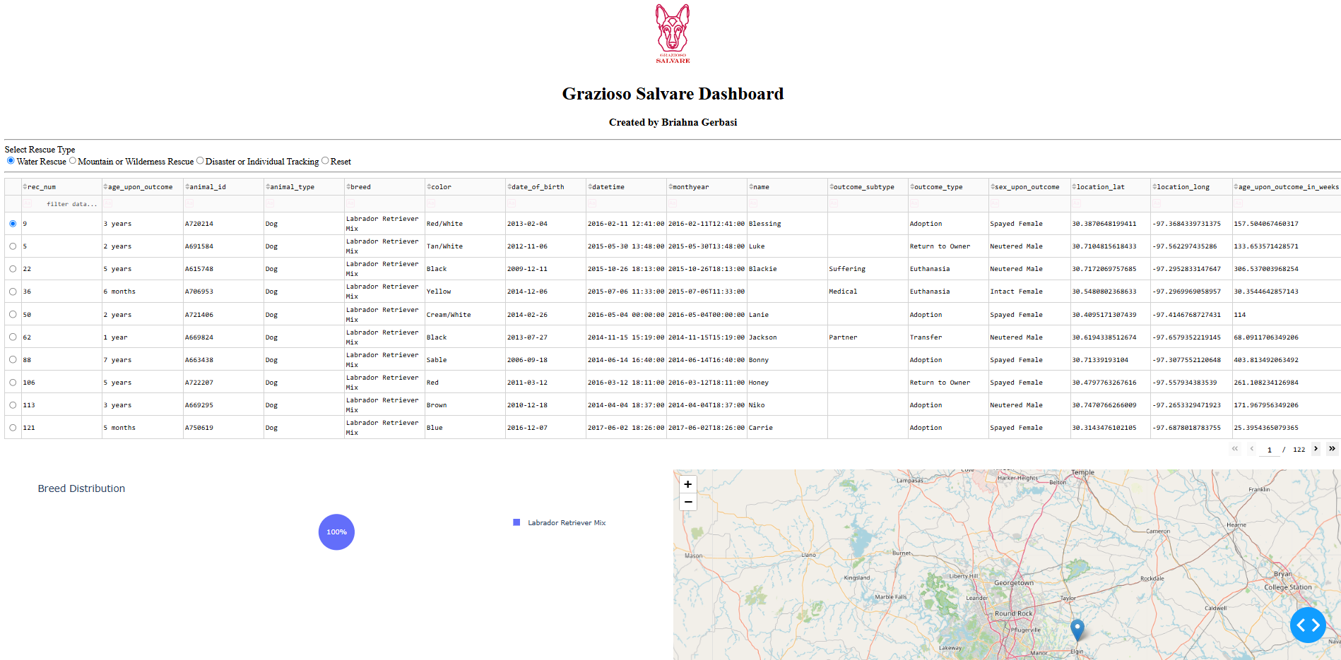
Screenshot 2: Water Rescue Filter

Screenshot 3: Mountain or Wilderness Rescue Filter
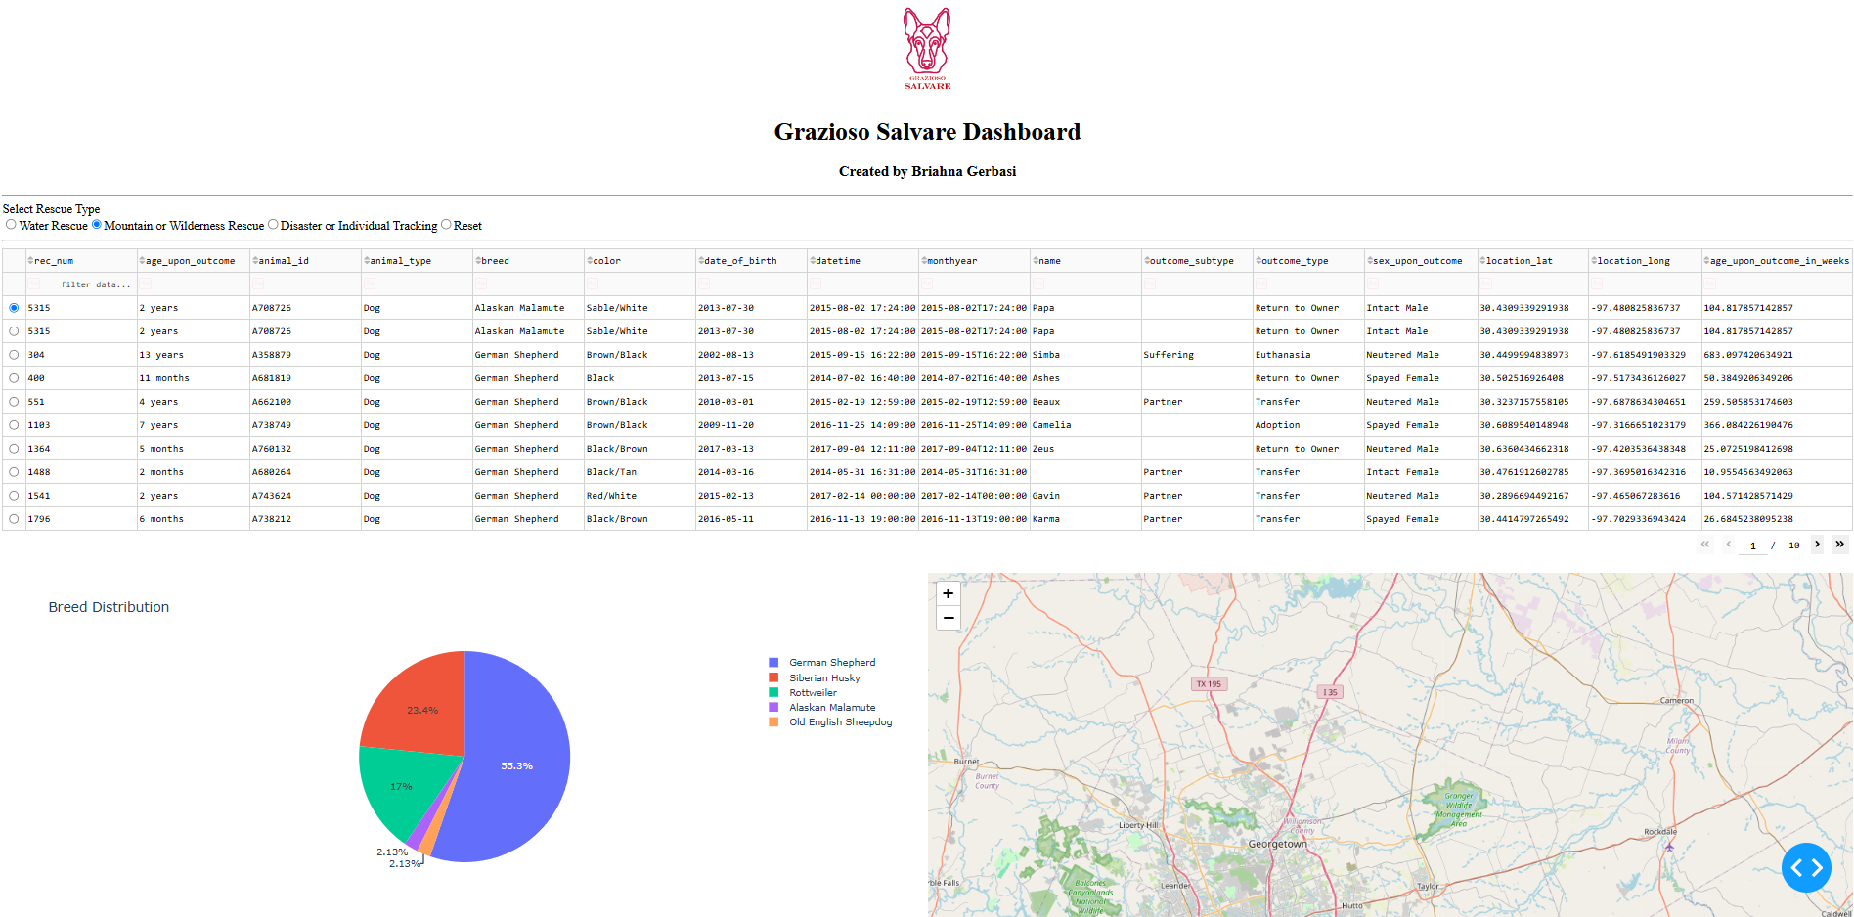

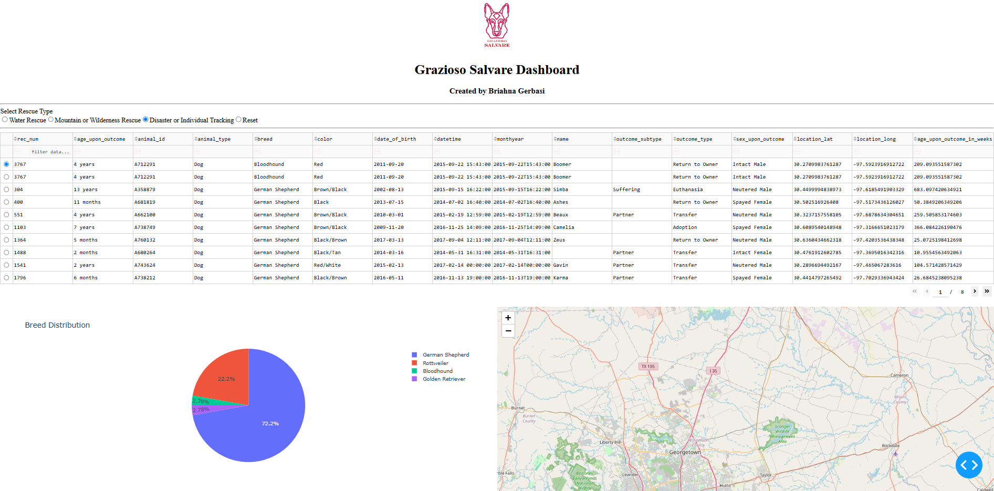
Screenshot 4: Disaster or Individual Tracking Filter

Tools and Technologies Used
Several tools were used to complete this project.
Python was used because it provides an easy way to connect to databases and build applications. MongoDB was used to store animal shelter data and serve as the database for this project. MongoDB works well with Python because the data is stored in a document format that is similar to Python dictionaries.
The Dash framework was used to create the dashboard interface. Dash made it possible to create an interactive web application using only Python. Pandas was used to organize and display data from MongoDB. Plotly Express was used to create the pie chart, and Dash Leaflet was used to create the interactive map.
Why MongoDB Was Used
MongoDB was used as the database because it stores information in a flexible document format that works well with Python. This made it easier to retrieve and display data within the dashboard. MongoDB also supports fast queries, which allowed the dashboard filters to update the data quickly when different rescue categories were selected.
The CRUD module created in Project One acted as the connection between MongoDB and the dashboard. This helped keep the database logic separate from the dashboard code.
Why Dash Was Used
Dash was used because it provides an easy way to create interactive dashboards without needing to use additional web development languages. Dash supports tables, charts, maps, and user input controls, all within Python. It also uses callbacks that automatically update dashboard components whenever the user interacts with the application.
Using Dash made it possible to connect the rescue filters to the data table, pie chart, and map so that all components update together.
Steps Taken to Complete the Project
I started by using the CRUD module from Project One to connect the dashboard to the MongoDB database. Once the connection was working, I loaded the shelter data into a Pandas data frame.
Next, I created the dashboard layout and added the Grazioso Salvare logo and my name. I then added radio button filters that allow users to select different rescue categories.
After the filters were created, I developed MongoDB queries for each rescue category and connected them to the data table through Dash callbacks. Once the table was updating correctly, I added the pie chart and geolocation map and connected them to the filtered data.
Finally, I tested each filter to make sure the data table, chart, and map updated correctly and captured screenshots showing the dashboard in each required state.
Challenges and Solutions
One challenge I faced was getting the dashboard to connect correctly to the CRUD module and MongoDB database. This was resolved by verifying the module name, class name, username, and password information.
Another challenge involved fixing callback errors in Dash. Some callbacks were failing because data was not available when the dashboard first loaded. Adding validation checks helped prevent these errors and allowed the dashboard to load correctly.
The final challenge was making sure all dashboard components updated together when a rescue filter was selected. After testing each filter and adjusting the MongoDB queries, the table, pie chart, and map all responded correctly.

References
Austin Animal Center. (2020). Austin Animal Center Outcomes [Data set]. City of Austin, Texas Open Data Portal. https://data.austintexas.gov/Health-and-Community-Services/Austin-Animal-Center-Outcomes-10-01-2013-to-05-05-/9t4d-g238/about_data
MongoDB. (n.d.). MongoDB documentation. https://www.mongodb.com/docs/
Pandas Development Team. (n.d.). Pandas documentation. https://pandas.pydata.org/docs/
Plotly Technologies Inc. (n.d.). Dash documentation. https://dash.plotly.com/

